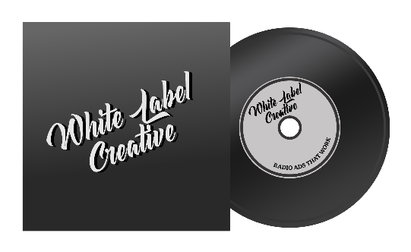

Creative brief

Client:
Durations: 15/30/45/60 seconds
Stations:

ads@whitelabelcreative.com.au
www.whitelabelcreative.com.au

WHAT ARE WE TRYING TO ACHIEVE IN MARKETING TERMS?
(e.g. gain market share through increased trial, reinforce customer loyalty etc)

WHAT DO WE WANT THE RADIO ADVERTISING TO DO WITHIN THIS?
(the contribution which radio can realistically be expected to make)

WHO ARE WE TALKING TO?
(by age/sex class etc, and also related to our brand - what do they currently think / feel about us? mention any secondary target groups e.g. rivals, trade etc)

DESIRED RESPONSE: WHAT DO WE WANT THEM TO THINK / FEEL / DO AS A RESULT OF THE RADIO CAMPAIGN?
(realistic ambitions please; consider any secondary target audiences)

WHAT DO WE WANT TO SAY TO THEM? / THE PROPOSITION
(single-mindedness is essential here; supporting information goes below)

SUPPORTING INFORMATION
(why should they believe us or find our message relevant or interesting?)

TONE OF VOICE
(how do we want to come over, in brief)

MANDATORY INCLUSIONS (IF ANY)
(e.g. website, sonic logo etc.. state if they could be included within the ad)

